User Specifications

Conformance Process for Specification and Acceptance Testing of LASC Communication Protocol

VERSION:1.0 | REVISION DATE: 11/10/2009

Approver Name | Title | Signature | Date
Table of Contents
Conformance Process for Specification and Acceptance Testing of LASC Communication Protocol 1
1. Introduction 3
1.1 Project Purpose 3
1.2 Project Scope 3
1.3 Stakeholders 4
1.4 Contact information 5
2. Requirements 6
2.1 Business requirements 6
2.1.1 Component 1. Guidelines for specifying automation systems 6
2.2 Functional Requirements 6
2.2.1 Component 1. Software framework for Level 1 compliance testing 6
2.2.2 Component 2. Software modules for Level 2 LASC-compliance testing 8
2.2.3 Component 3. Software framework for Test case management 9
2.3 Non-functional requirements 10
2.3.1 Performance requirements 10
2.3.2 Security requirements 10
2.3.3 Safety requirements 10
2.3.4 Hardware requirements 10
2.3.5 Data requirements 10
2.4 Operation requirements 11
2.4.1 Reliability 11
2.4.2 Recoverability 11
2.4.3 System Availability 11
2.4.4 Data Retention 11

Introduction
The aim of the project is to develop an industry-based conformance process for specification and acceptance testing of ACARP-developed technologies. For LASC technologies, a set of software tools will be produced to assist specification and conformance testing of OEM implementations against existing open LASC specifications. The framework for this process will also be able to accommodate future automation systems. Both manufacturers and customers will have open access to the software tools and each can test OEM automation systems for conformance with the LASC (and future) specifications.
The major benefit of this project is that it will assist the delivery of automation systems that are able to be accurately specified and will define compliance that is able to be accurately verified by operators that are not necessarily leaders in automation technology. Moreover, a climate of industry leadership in setting automation standards will be achieved. Comparisons with the JORC code for mineral resources and IEEE standards for networking can be made.

Project Purpose
A key outcome of the ACARP Landmark longwall automation projects (C10100 and C15002) has been the development of the coal industry’s first open specifications for the exchange of sensing and control information between longwall face equipment. These specifications were developed at the direction of the ACARP Longwall Automation Steering Committee (LASC) to eliminate any “black box” issues in the implementation of Landmark project outcomes (now called LASC automation systems). These specifications mean that any equipment manufacturer implementing LASC technology knows exactly how to communicate with the automation system and what the data means. Because on one face, different OEMs (shearer and face) could be implementing different aspects of LASC technology, equally important is the fact that the different OEM implementations will also be compatible and will communicate with each other. Moreover, this is all visible to the customer who will not be confronted by vendor-specific black boxes.
Customers need to be able to specify equipment against the open LASC specifications and be confident that equipment they subsequently purchase will comply with them. It is unlikely in the short term that the OEMs will form an alliance or monitoring group to maintain open specifications so another mechanism is required to maintain the freedom of customers to select longwall equipment of their choice and exploit the significant LASC automation advances which have been demonstrated so far in an open systems environment.
At the moment there is inherently no such mechanism to achieve this and this is the problem being addressed directly by this proposal.

Project Scope
The purpose of the project is to develop a method by which the compliance of OEM control systems with Industry automation specifications can be verified thus maintaining ACARP’s desired uniform application of open specifications. This solution will consist of two major components.
The first component will be documentation explaining the general principles and scope of available Industry specifications with guidance for inclusion in tender processes. As well as containing general information this will initially concentrate on longwall automation and will be updated as further application areas are added.
The second component will be software modules, freely available to manufacturers and equipment customers, which will be used to verify the compliance of OEM equipment. Initially the software will concentrate on the longwall automation area. It will communicate with the control system of each new longwall equipment item or sensor produced by each supplier to ensure that all aspects of the information flow comply with the specifications. The software will then generate reports on the level of compliance of the OEM equipment to the LASC specifications.
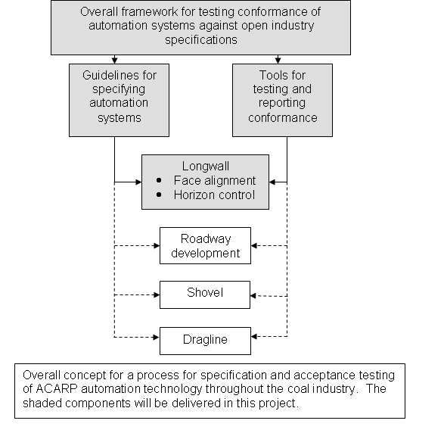
The diagram below outlines the vision for a general conformance process.

For LASC automation systems, the equipment procurement and acceptance process will then be as follows.
Equipment is specified by the customer against the open, published LASC specifications.
The proposed test software will be used by OEMs to generate certificates of compliance.
Manufacturers include test results in their tenders for inspection by the customer.
Customers can also independently run the test software on supplied equipment as part of compatibility and site acceptance testing.
This process will ensure that LASC automation systems such as face alignment and horizon control will operate successfully with shearer and shield systems supplied by different vendors.

Stakeholders
ACARP
CSIRO E&M
Joy
Bucyrus
Eickhoff
Inbye
Kopex

Contact information
Contact David Reid
Phone 07 3327 4437
Fax 07 3327 4566
Email david.reid@csiro.au

Requirements

Business requirements
This section covers any organisation specific requirements, such as corporate colours, interface models etc.

Component 1. Guidelines for specifying automation systems
This section covers the creation of generic documentation for full and complete specification of a new automation system.
A LASC conformance Specification is will be created to specify the process and requirements for LASC compliance.
In addition, standard templates will be generated for new implementations of LASC interoperable applications or devices.
The following are requirements for generic specifications:
- Overview
- Scope
- Control Algorithms
- EIP Object model
- LASC level 1 certification report
- LASC Level 2 test module and documentation

Functional Requirements
This section covers all system features, including user interface, algorithm implementation, control operations, external interface requirements etc
The minimum set of Level 1 functionality will be as per the document ‘LASC Level1 Specifications’

Component 1. Software framework for Level 1 compliance testing
- broad level ‘look and feel’ system requirements,
- work flow requirement,
- test case outlines; and
- reporting requirements.
This component will consist of a stand alone application for testing LASC compliance.
The initial screen will display the options for running the software:
- Test identification Fields (Tester name and Device Description)
- Testing Device (server) or Master (client)
- Remote test TCP/IP address
The initial screen will have a ‘Start Testing’ button.
Example :
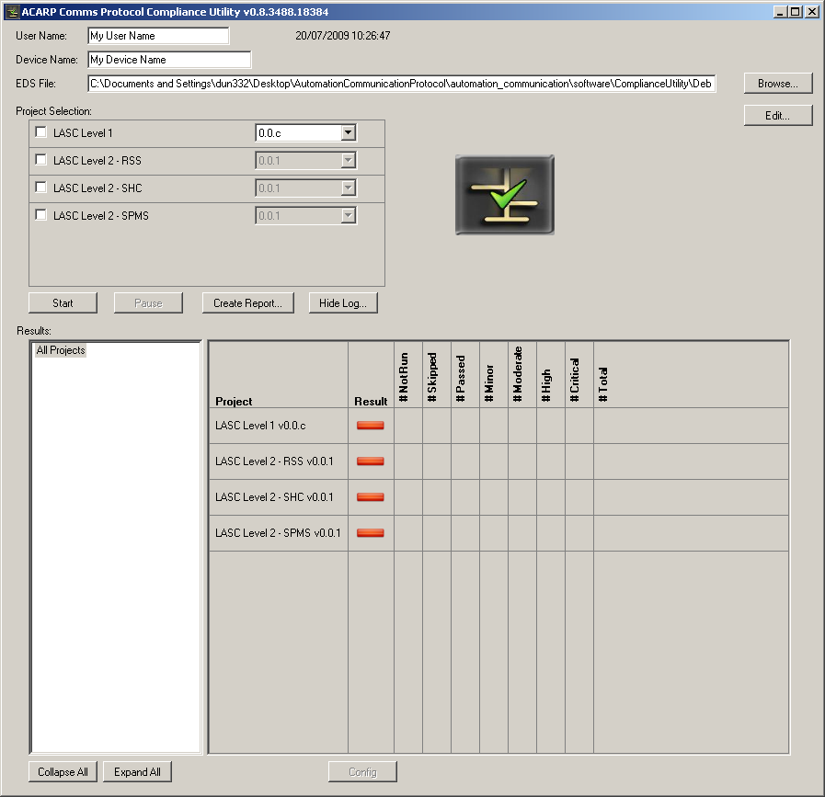

When the user hits Proceed, the testing will commence. The user interface will have a progress status display and a cancel function.
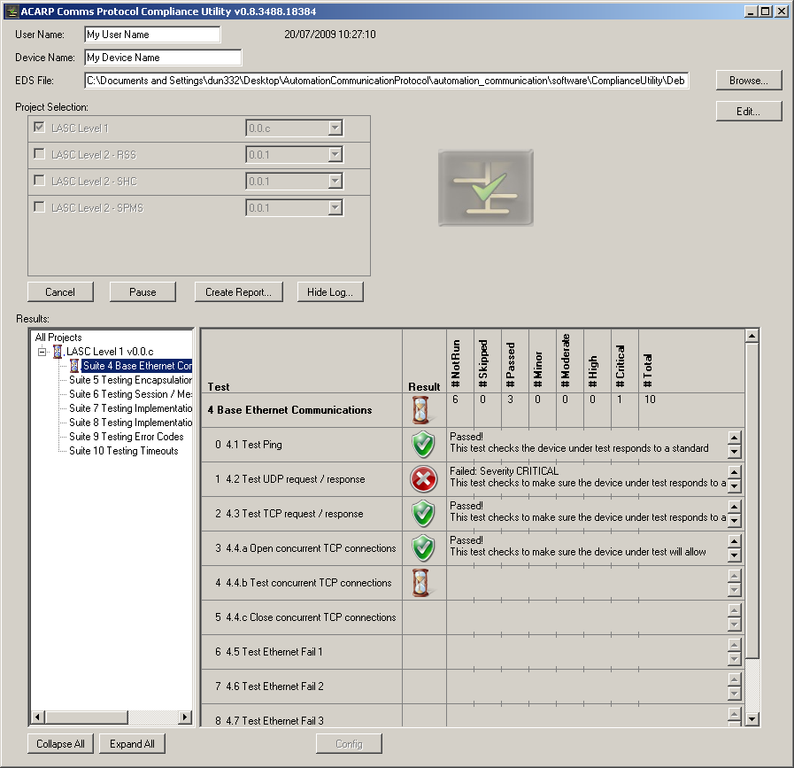

On start up, the testing application will check for the existence of add-in modules in the install path. Each add-in module will be checked and added as a tab on the main page. If there are any existing add-ins, the testing functionality will be launched from that tab via a check box. There may be specific options relevant to that module only, these options may be selected from the relevant tab.

Component 2. Software modules for Level 2 LASC-compliance testing
This component focuses on the production of modules for testing the existing systems in (or approaching) production. This testing is referred to as Level 2 LASC-compliance <module name>. These modules will be created as ‘plug-ins’, or optional components of the base software created and delivered in component 2 above. These modules will each produce a separate report page and the main software will identify which optional components are installed and create a summary in addition to the Level 1 testing report.
The main focus of these modules will be testing the functional capabilities of the system in test. The functionality tests are formally defined in the respective module specification. The methodology for defining and encoding terms such as ‘function’, ‘test inputs’, ‘expected results’ will be specified in component 1) above.

Generic details/loading details
Each module will be written as an extension to the main testing utility. The install process will load either a file onto the install path, or details into the registry.
Each module will define specific functionality to be tested on the device. These tests will be of the format:
Input - <Trigger> - Process - Output
Each test will have a short description (e.g. ‘test heartbeat’)
Each test input may contain 0-many parameters. (e.g., packet containing: class, instance)
Each parameter may contain valid ranges
The process may consist of 0-many steps
The process may consist of similar steps, or different steps

The output may contain 0-many parameters
The output may be a manual verification checkbox

In General, the main types of functional (process) testing are:
- < Trigger > and automatic verification via read back
- < Trigger > and manual verification
- < Trigger > and error response

Where < Trigger > may be:
- Data Transfer
- Power on/power down/power cycle
- Communications error/communications signal
- Random/set time delay from last < Trigger >

Specific functional modules
Specific testing modules will be created for:
- RSS functional test module plug in,
- Shearer functional plug in,
- SPMS functional test module plug-in

OEM accessible SPMS functional test module plug in (EIP segment)

Component 3. Software framework for Test case management
This component consists of an application to generate and check test module xml files. This software will allow loading, saving and editing of xml formatted test files.
This software will allow loading, editing and saving of exml files to users with the appropriate authorisation (password protected)

Non-functional requirements

Performance requirements
The testing system should run autonomously after the initial user interface option selection phase. Any manual events will notify the user to take action.
Any errors should produce a report at the output phase, NOT cancel the program.

Security requirements
The output of the testing should be digitally signed in some way to prove that this testing run has been completed using a verified testing utility.

Safety requirements
Note that this system should only be run on systems that are connected in testing mode only. There may be unforseen and unintentional consequences brought about by the purposeful introduction of corrupt or badly formed instructions.
The systems (especially devices with physical interactions) MUST be constrained in a safe manner. This constraint will be the responsibility of the testing operator or the system owner.

Hardware requirements
This testing software will be available in a Windows operating environment only.

Data requirements
The results of the testing run should be saved, along with any other relevant information (time, date, hardware details) in a format that can be reviewed or summarized at a later date.

Operation requirements

Reliability
n/a

Recoverability
n/a

System Availability
n/a

Data Retention
n/a

Version | Description of Change | Author | Date
1.0 | Created | Mark Dunn | 4/2/08

